ProjectPlanningPhase

SPRINT-1

|  |  |
| --- | --- |
| Date | 4November2022 |
| TeamID | IBMSI20220041672 |
| ProjectName | IOT BASED SAFETY GADGET FOR CHILDMONITORINGAND NOTIFICATION |

USN1:Asa userIneedto enrolthecloudregistration

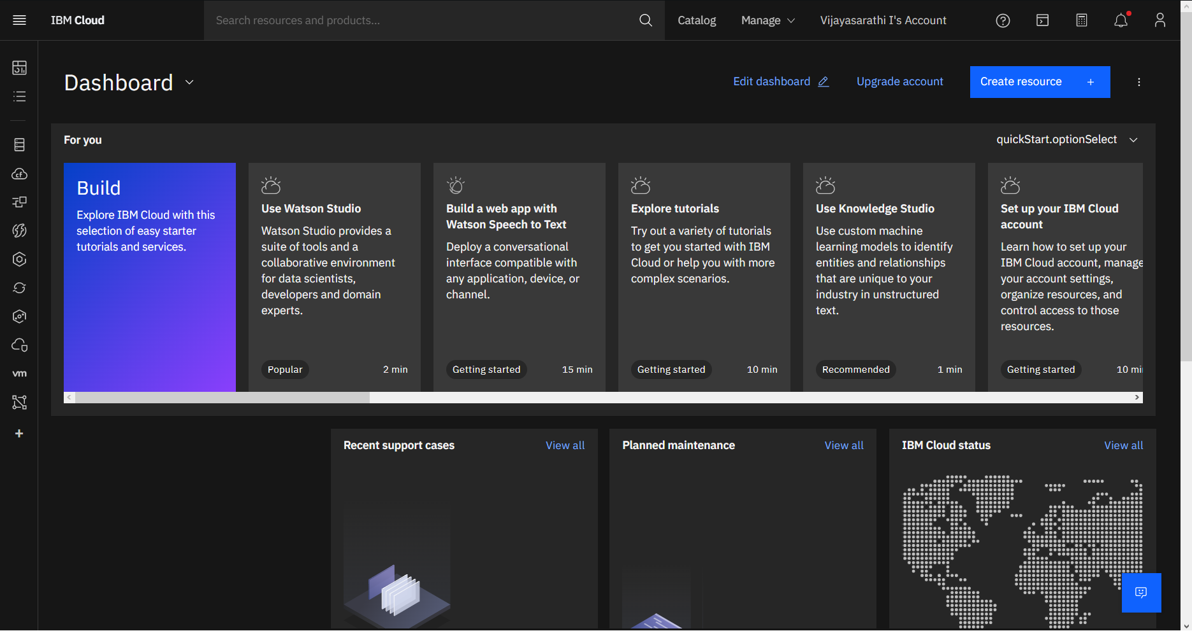

USN2: Aftercreatingcloudaccountlaunch IBMWatsonIOTplatformbyaccessingcloud account

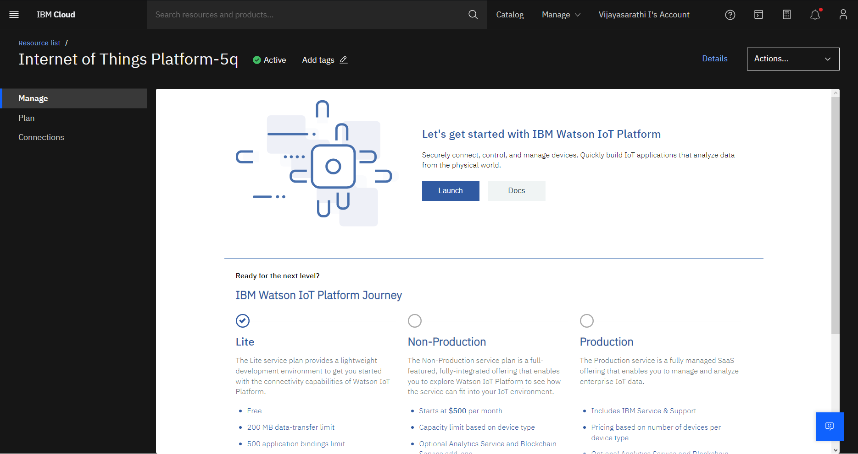

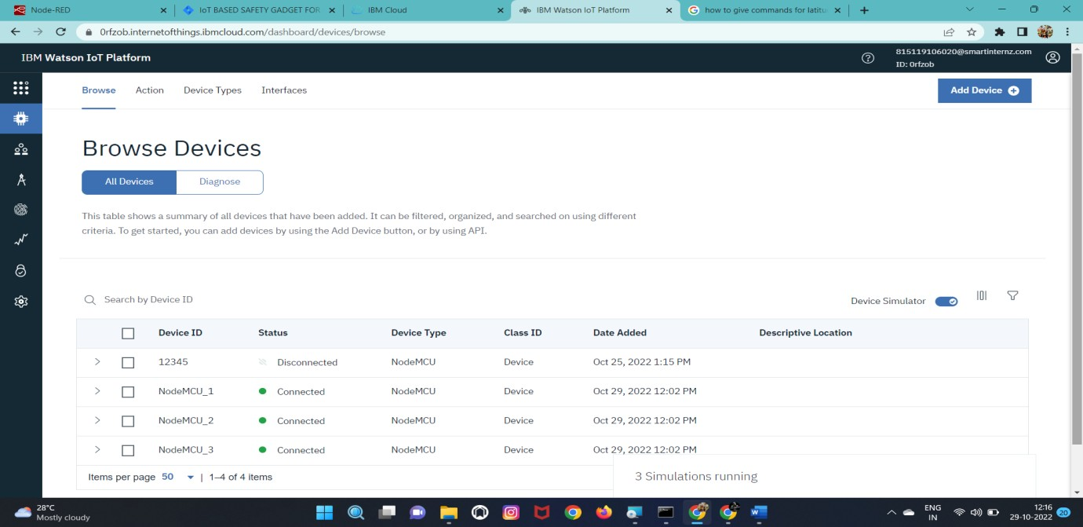USN3: Createthenodein IBMWatsonplatform

USN4:AfterCreatingnodegetdeviceTypeandid

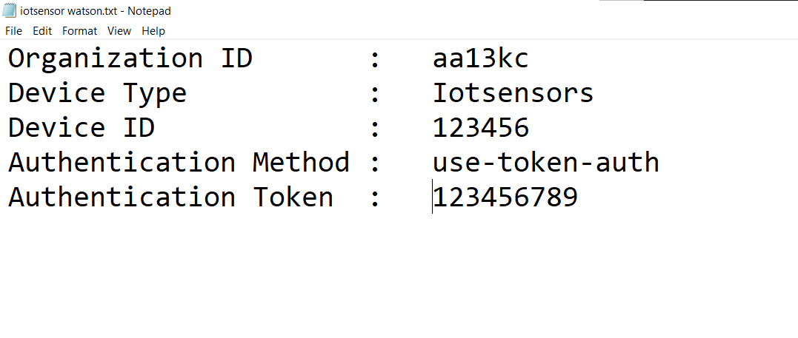

USN6: Simulatethenodecreated

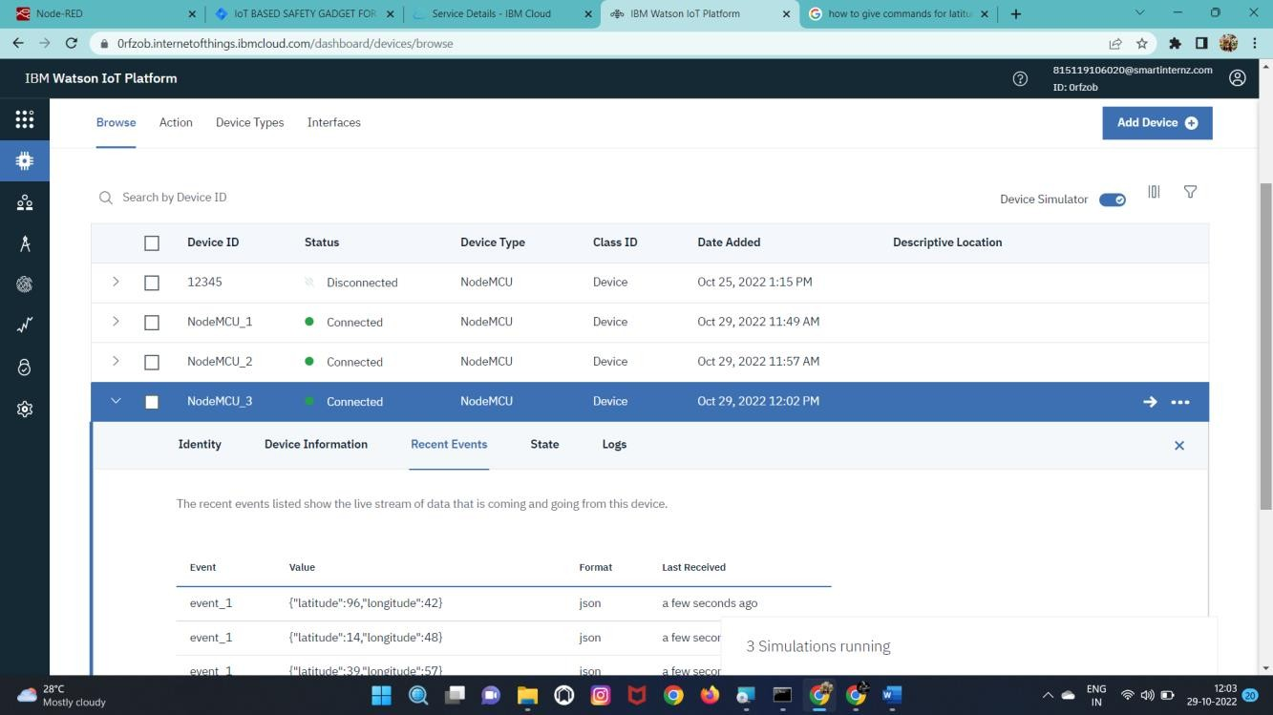

# BURNDOWNCHART:

# 

# VELOCITYCHART:

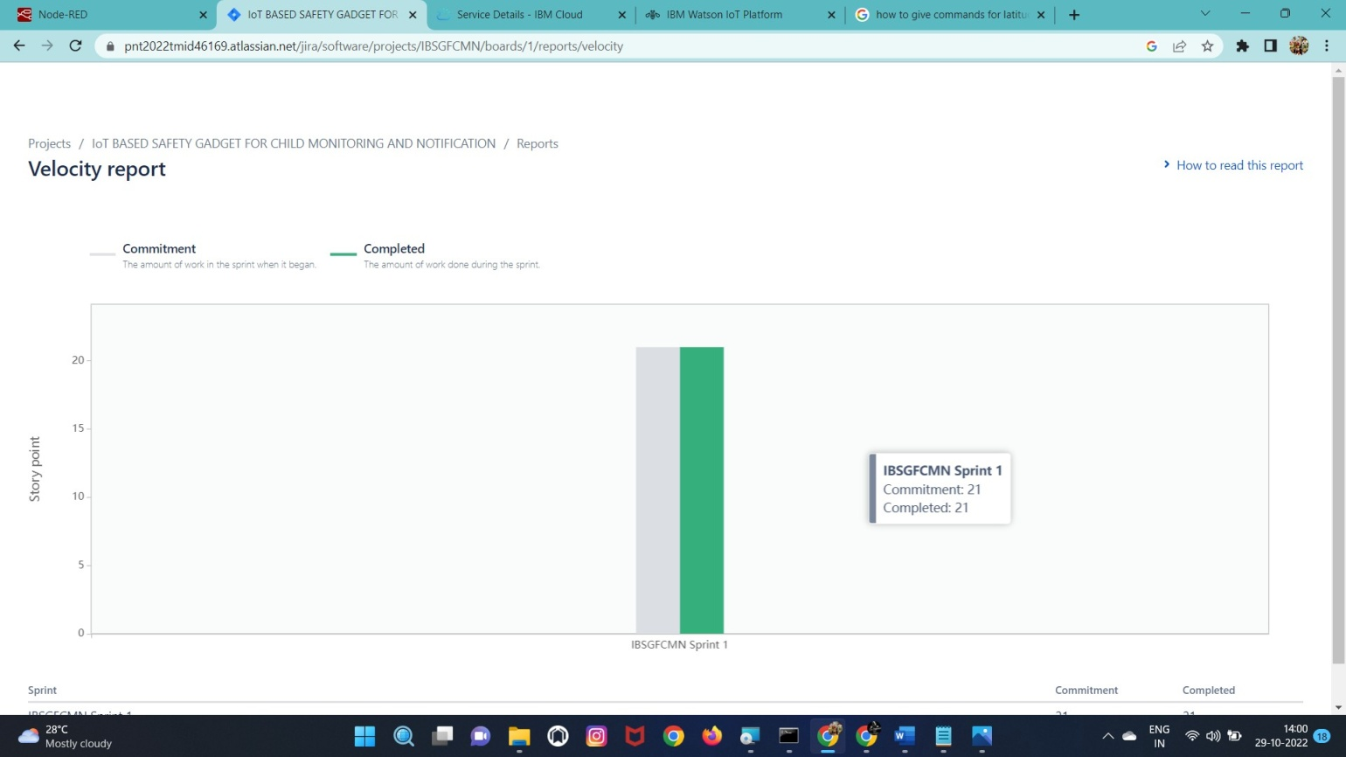

# ROADMAP:

